# Install Python 3.7

**Step 1. Find out the latest version of Python.**

<https://www.python.org/ftp/python/>

**Step 2. Install Python**

sudo apt-get install python3-dev libffi-dev libssl-dev -y

wget https://www.python.org/ftp/python/3.7.6/Python-3.7.6.tar.xz

tar xJf Python-3.7.6.tar.xz

cd Python-3.7.6

./configure

make

sudo make install

sudo pip3 install --upgrade pip

**Step 3. Update Python**

sudo nano ~/.bashrc

Add at the end of the file alias python3=python3.7

Save and enter source ~/.bashrc

**Step 4. Check whether Python is installed**

python3 --version

# Install Tensorflow and Keras

**Step 1. Install libraries**

sudo apt-get install python3-numpy

sudo apt-get install libblas-dev

sudo apt-get install liblapack-dev

sudo apt-get install python3-dev

sudo apt-get install libatlas-base-dev

sudo apt-get install gfortran

sudo apt-get install python3-setuptools

sudo apt-get install python3-scipy

sudo apt-get update

sudo apt-get install python3-h5py

**Step 2. Install Tensorflow 2.0**

Download the latest version of Tensorflow

<https://github.com/lhelontra/tensorflow-on-arm/releases/>

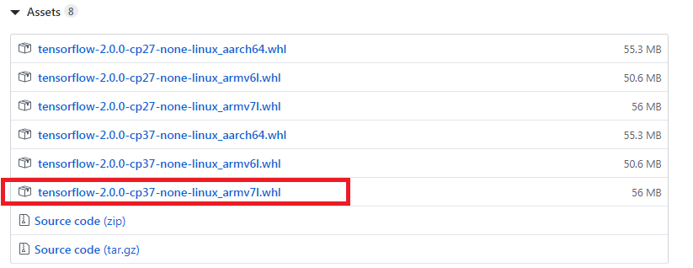

sudo pip3 install tensorflow-2.0.0-cp37-none-linux_armv7l.whl

**Step 4. Check whether Tensorflow 2.0 is installed**

pip3 list | grep -i tensorflow

**Step 3. Install Scipy**

Download the latest version of Scipy

<https://www.piwheels.org/simple/scipy/>

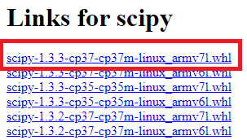

sudo pip3 install scipy-1.3.3-cp37-cp37m-linux_armv7l.whl

**Step 3. Install Keras**

$ sudo pip3 install keras

**Step 4. Check whether keras is installed**

$ pip3 list | grep -i keras

**Note:**

1. The default Python IDE Thonny has its own enivironment. It could have “no module is found “ after installation.
2. Install Tensorflow before Keras. Otherwise, Keras installation may be failed.

# Install OpenCV4

**Step 1. Check the latest OpenCV at following link.**

<https://github.com/sol-prog/raspberry-pi-opencv/releases/>

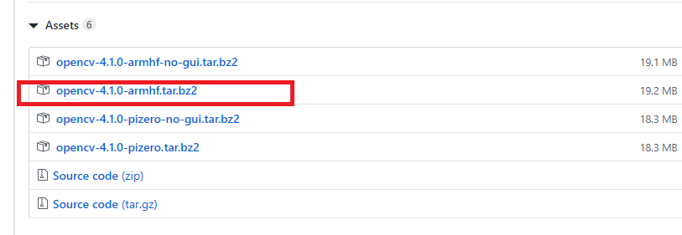

**Step 2. Download OpenCV**

$ wget <https://github.com/sol-prog/raspberry-pi-opencv/releases/download/opencv4rpi2.1/opencv-4.1.0-armhf.tar.bz2>

$ tar xfv opencv-4.1.0-armhf.tar.bz2

**Step 3. Install dependencies**

$ sudo apt install libgtk-3-dev libcanberra-gtk3-dev

$ sudo apt install libtiff-dev zlib1g-dev

$ sudo apt install libjpeg-dev libpng-dev

$ sudo apt install libavcodec-dev libavformat-dev libswscale-dev libv4l-dev

$ sudo apt-get install libxvidcore-dev libx264-dev

$ sudo apt install python-numpy python3-numpy

$ sudo apt-get install qt4-dev-tools

**Step 4. Install OpenCV 4**

$ sudo pip3 install opencv-python

**Step 5: Issue fix undefined symbol: __atomic_fetch_add_8**

$ export LD_PRELOAD=/usr/lib/arm-linux-gnueabihf/libatomic.so.1 >> .bashrc

$ . .bashrc

**Step 6: Check whether OpenCV is installed.**

$ Import cv2

**Reference:**

* <http://www.knight-of-pi.org/installing-python3-6-on-a-raspberry-pi/>
* <https://www.teknotut.com/en/install-tensorflow-and-keras-on-the-raspberry-pi/>
* <https://solarianprogrammer.com/2019/09/17/install-opencv-raspberry-pi-raspbian-cpp-python-development/>